**Mars Rover Challenge**

**Created By: Marius Minnie**

**Contact No: 066 286 2168**

**Email:** [**minas152@gmail.com**](mailto:minas152@gmail.com)

Assumptions

* The input parameter is a string array.
* The output is a string array.
* The rovers cannot exit the plateau.
* In order of the array the rovers cannot drive over each other.
* When incorrect command is given exception must be thrown.

Because the interview stated that the position available is a .Net Developer, I thought it would be more fitting to create a AspnetCore Web API instead of a normal console app.

The API is published with the self-contained option. Meaning no dependencies are required to run the app. Simply navigate to the “MarsRoverChallengePublished” folder and double click on the “MarsRoverChallenge” application file.

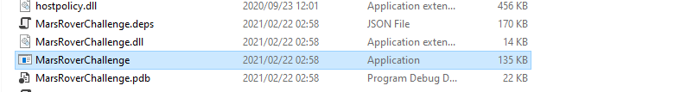

Afterwards a console screen will popup giving the api hosting information and running the application. Leave this screen open.

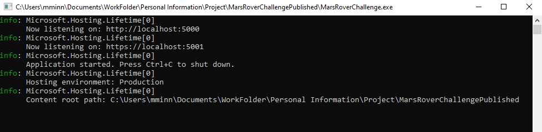

Now open up any browser and go to the web address <http://localhost:5001>

If the port is already in use on your computer please check the console to see what port the API is hosted on.

By default, a swagger interface will appear once navigating to the address.

Click on the API method listed and click on the “Try it Out” button. This will open up input request body box where the input parameters can be inserted in a string array format.

Afterwards Click on the execute button and the result will appear in the response block.

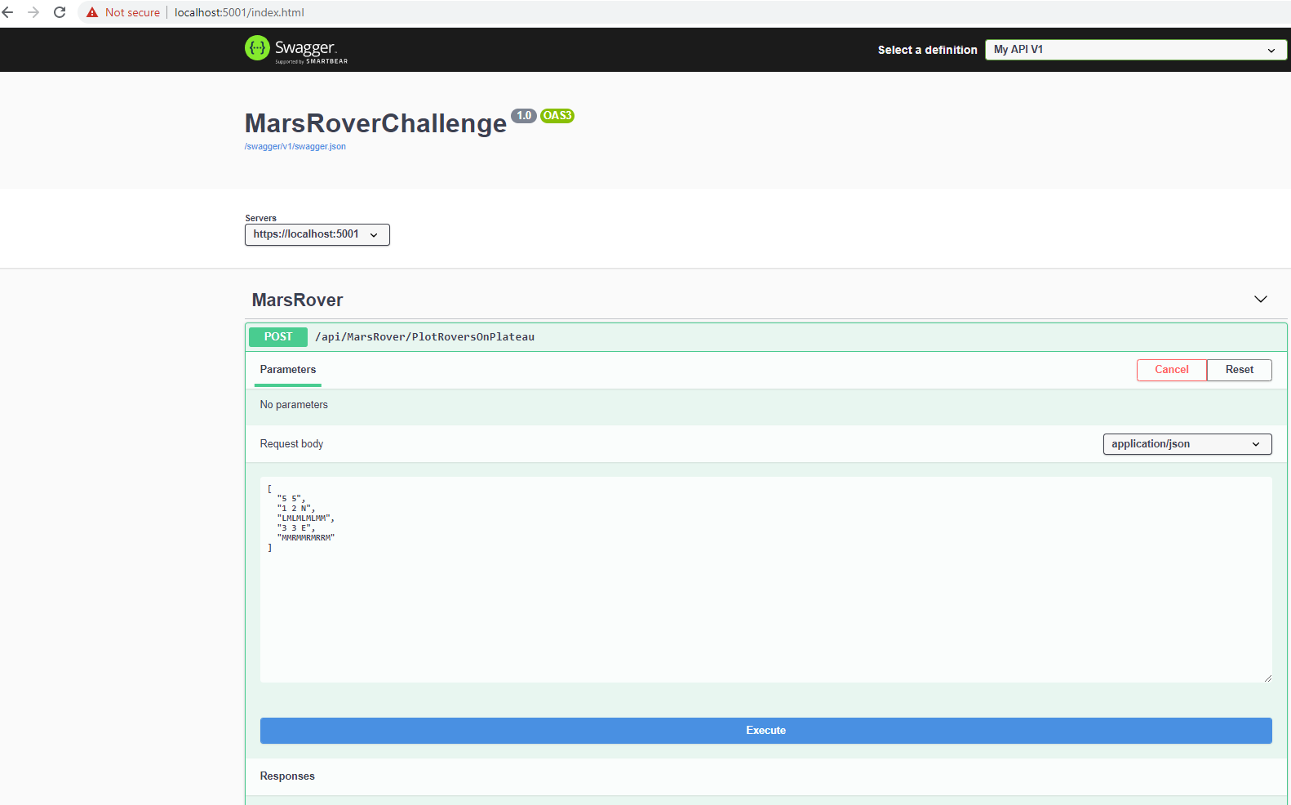

Thank you very much for the chance to develop this fun project and thank you for your time in reviewing this.

This project Was Created on Visual Studio 2019.

The Target Framework is .Net Core 3.1